TE MINI-PROJECT REPORT ON

# Bank Management System

by

|  |  |
| --- | --- |
| Rishab Anil M | 60004190091 |
| Rushi Desai | 60004190096 |
| Saloni Patel | 60004190099 |

Project Link: <https://github.com/saloni3121/Python-Mini-Project.git>

Under the guidance of

Prof. Ashok Patade

**ABSTRACT**

This project aims at creation of a secure Internet banking system. This will be accessible to all customers who have a valid User Id and Password. This is an approach to provide an opportunity to the customers to have some important transactions to be done from where they are at present without moving to bank. In this project we are going to deal the existing facts in the bank i.e.; the transactions which takes place between customer and bank. We provide a real time environment for the existing system in the bank. We deal in the method transaction in the bank can be made faster and easier that is our project is an internet based computerized approach towards banking.

### CONTENTS

|  |  |  |
| --- | --- | --- |
| **Chapters** | **Title of Chapters** | **Pages** |
| Chapter 1 | Introduction | 7 |
| Chapter 2 | Aims and Objectives | 8 |
| Chapter 3 | Literature Survey | 9 |
| Chapter 4 | Proposed System | 10 |
| Chapter 5 | Software used | 11 |
| Chapter 6 | Implementation | 12 |
| Chapter 7 | Flowchart | 13 |
| Chapter 8 | ER- Diagram | 14 |
| Chapter 9 | Output | 15-18 |
| Chapter 10 | Conclusion | 19 |
| Chapter 11 | Acknowledgement | 20 |
| Chapter 12 | References | 21 |

#### CHAPTER-1

##### INTRODUCTION

The main aim of the project is to cover the basic functionality of a bank management system. It is used for solving financial application of a customer in banking environment in order to nurture the needs of an end banking user by providing various ways to perform banking tasks.

The main objective of the project is to develop online Banking system for banks. In present system all banking work is done manually. User have to visit bank to Withdrawal or Deposit amount. In present bank system it is also difficult to find account information of account holder. In this bank management system we will automate all the banking process. In our bank management system user can check his balance online and he can also transfer money to other account online. In this Software you can keep record for daily Banking transactions. The main purpose of developing bank management system is to design an application, which could store bank data and provide an interface for retrieving customer related details with 100% accuracy.

The system will check the user’s existence in the database and provide the set of services with respect to the role of the user.

#### CHAPTER-2

##### AIMS AND OBJECTIVES

**AIMS:**

To make a software to help the customers to access the services of the bank online using PYTHON.

**OBJECTIVES:**

* The main object of this system is to provide a secure system. Our system is password protected and it only allows authorized user to access various functions available in the system.
* It will Reduced manual work as most of the work done by computer. As all the manual work will be done automatically so it will increase work speed and reduce time consumption to complete any bank related work.
* It will also increase the work efficiency as few employees can handle more customers. This will reduce the manual workload and give information instantly.
* Through this bank management system user can manage all bank account activity like deposit money, withdraw money, check balance and change pin number.
* The project makes a sincere effort to provide all the below-mentioned features to meet the requirements of the bank.

**CHAPTER-3**

**LITERATURE SURVEY**

|  |  |  |  |  |
| --- | --- | --- | --- | --- |
| Sr No. | Title of the  Paper | Author of the paper | Published year | Inference |
| 1 | Banking  Comprehensive  Risk  Management System based on Big data Architecture of hybrid processing Engines and  Databases | Shenglan Ma, Hao  Wang , Botong Xu,  Hong Xiao,  Fangkai Xie ,  Hong-Ning Dai ,  Ran Tao , Ruihua  Yi , Tongsen Wang | 2020 | This paper tells us that how Banks are shifting from simple credit risk Models to comprehensive risk models and provides innovative and effective solutions. It proposes Big Data Architecture of Hybrid processing engines and databases. The ecosystem used here is Hadoop with ETL and Spark processing engines and uses massive Databases, HDFS and transactional databases. |
| 2 | The implementation of E-money in mobile phone: A case study at  PT Bank KEB  Hana | Didik Haryadi,  Harisno, Victory  Haris  Kusumawardhana,  Harco Leslie  Hendric Spits  Warnars | 2019 | This paper tells us that due to innovations in cashless payments, it has been seen that the growth of E-money is growing faster than credit or debit cards for online payment transactions directly from the banks. This paper analyzes the design of the E-money and provides development ideas. |
| 3 | Design and Implementation of various  Payment  System for  Product  Transaction in  Mobile  Application | Dewi Sandy  Islamiati, Dias  Agata, Adnan  Rahmat Anom  Besari | 2019 | In this paper, a payment system is made on mobile applications and web services using REST API to connect client – server. This system helps in researching the authentication process of the system |
| 4 | Managing the Implementation of Banking Systems for  Repeatable  Success | Andre Malan , L  Pretorius , JHC  Pretorius | 2018 | The paper tells us how to manage the implementations for repeated success of banking system. Which models and technical requirements are important and should be focused are written in the paper. |

#### CHAPTER-4

##### PROPOSED SYSTEM

* It will have a registration page where the individual will have to register him/herself to access all the banking services.
* It will have a login page where only registered and authorized person can have access to the bank.
* The account number is automatically generated for the user by using which he/she can login in the system.
* It has a home page where all the services provided by this software will be visible.
* The withdraw module in this software will help the individual to withdraw money from the bank using his/her credentials.
* The deposit module will help the individual to deposit money in his/her A/c.
* All the new user account balance is credited with Rs.1000.
* The balance module helps the individual to check is/her balance after withdrawal and deposit transactions.
* The pin changing module helps the individual to update or reset his/her old pin number with the new one.
* It has a delete account page where the user can sent the request to the admin.
* It has a admin page where the admin can accept or decline the user request for deleting the user account.

#### CHAPTER-5

##### SOFTWARE USED

1. **Python IDLE 3.9**

IDLE (Integrated Development and Learning Environment) is an integrated development environment (IDE) for Python. The Python installer for Windows contains the IDLE module by default. IDLE can be used to execute a single statement just like Python Shell and also to create, modify, and execute Python scripts.

**Programming language used**

**Frontend**

1. **Python Tkinter**

Tkinter is Python's de-facto standard GUI (Graphical User Interface) package. It is a thin object-oriented layer on top of Tcl/Tk. Tkinter is not the only GUI Programming toolkit for Python.

It is however the most commonly used one. Tkinter is the standard GUI library for Python. Python when combined with Tkinter provides a fast and easy way to create GUI applications. Tkinter provides a powerful object-oriented interface to the Tk GUI toolkit.

**Backend**

1. **SQlite**

SQLite is an embedded SQL database engine.Unlike most other SQL databases, SQLite does not have a separate server process; it reads and writes directly to ordinary disk files. A complete SQL database with multiple tables, indices, triggers, and views, is contained in a single disk file.

SQLite is a software library that provides a relational database management system. The lite in SQLite means lightweight in terms of setup, database administration, and required resources. SQLite has the following noticeable features: self-contained, serverless, zero-configuration, transactional.

#### CHAPTER-6

##### IMPLEMENTATION

* The design and implementation of the bank management system is to replace the tradition way of using banking services.
* Registered users can directly access the services provided by the system.
* This system is especially designed for the customers to make use of the services efficiently and with ease.
* This system aims to provide the best services.

#### CHAPTER-7

**Flowchart:**

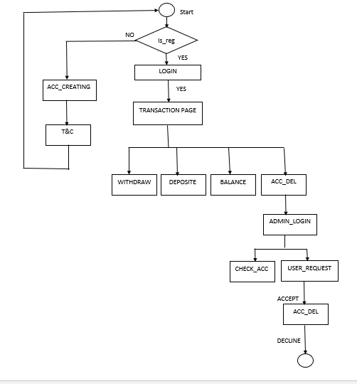

#### CHAPTER-8

**ER-Diagram:**

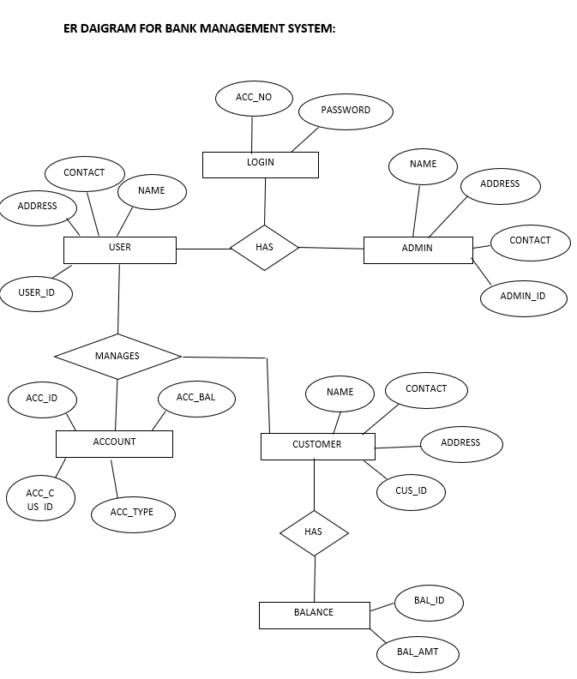

#### CHAPTER- 9

**Output:**

Home page

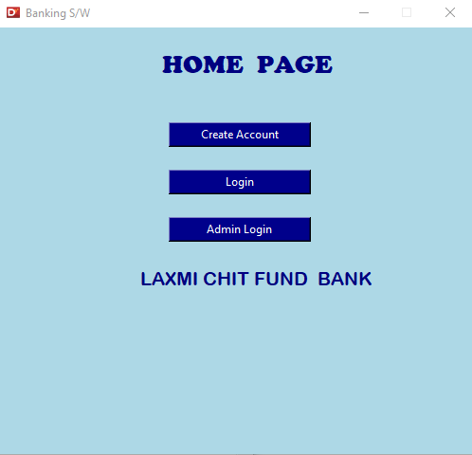

Terms and Conditions Page

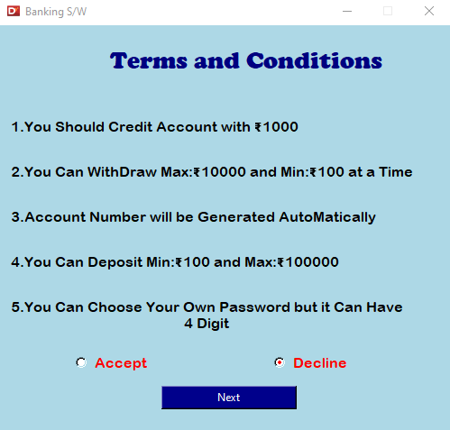

Account Generating Page

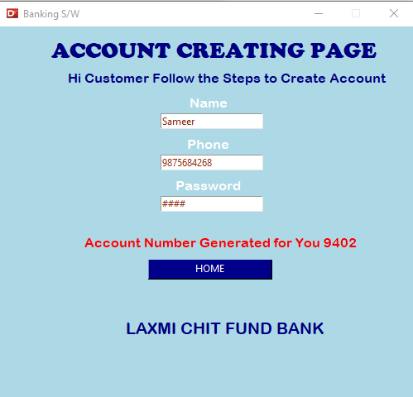

Login Page

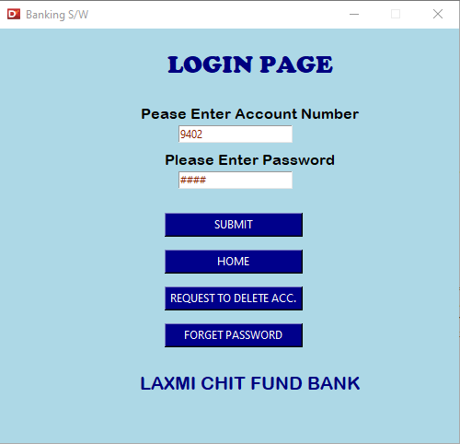

Transaction Page

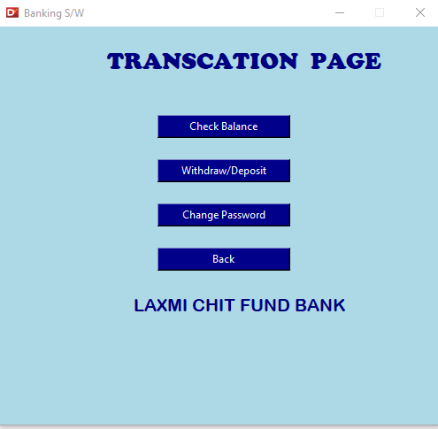

Balance

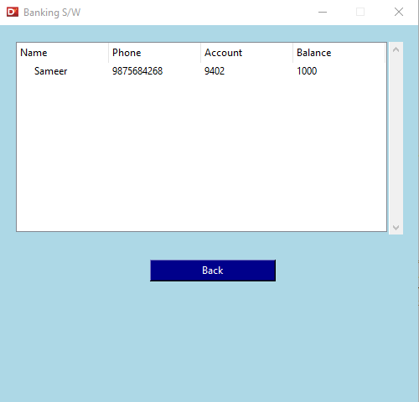

Withdraw\Deposit Page

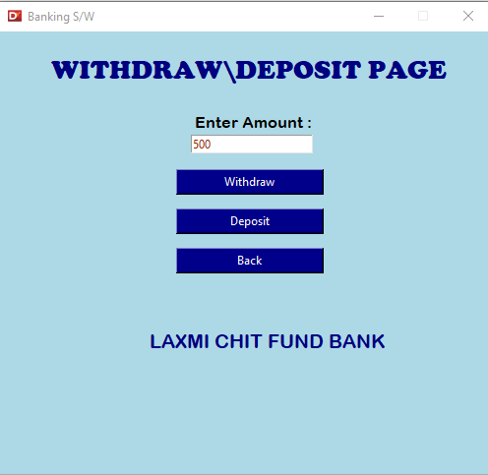

User Account Deleting Request

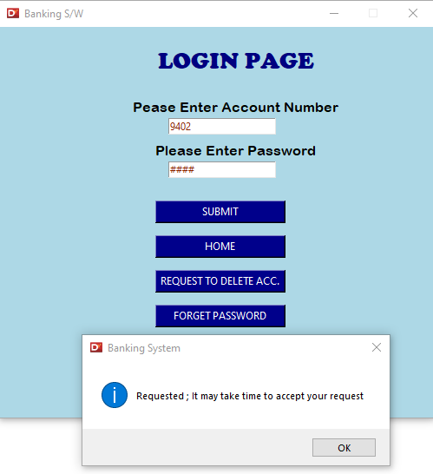

Admin Login

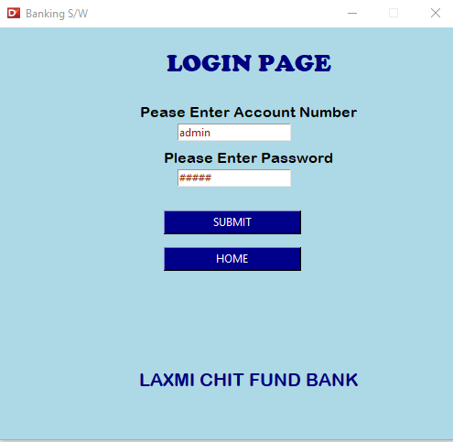

Admin Home page

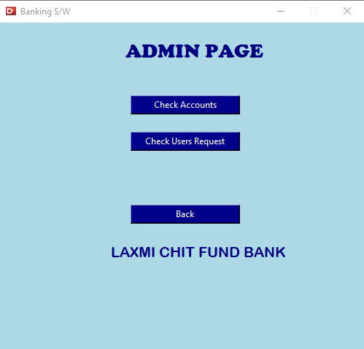

(Admin)Check User Accounts

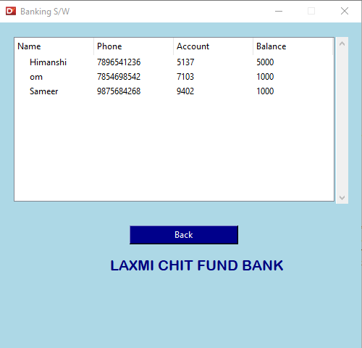

(Admin) User Request

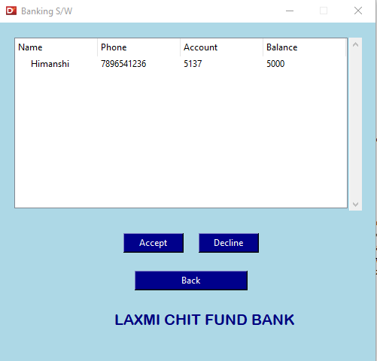

Password Changing Page

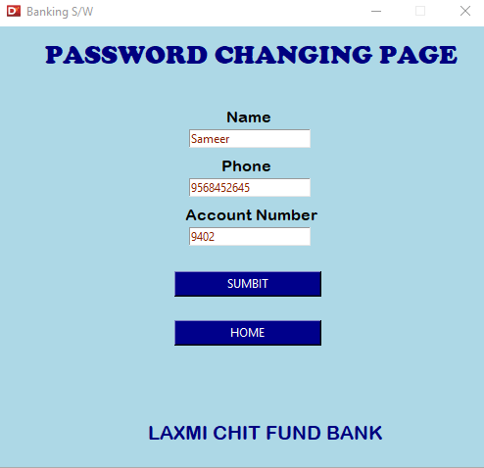

Change password Page

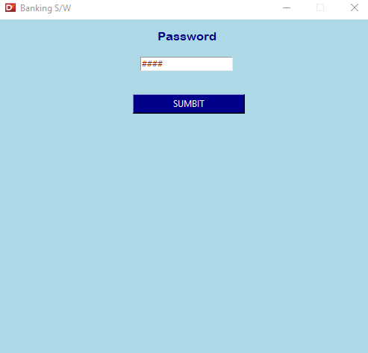

#### CHAPTER-10

**CONCLUSION:**

This reports concludes that banking sector has revolutionized through- out the nation. And almost all people are benefited by these software solutions. Adaptation to the customer needs is much necessary in the growing economy. Banks have understood the customer needs much accurately. This is a positive sign of growth. This paper once again reinforces the concepts of software solution banking. Much more customer friendly approach will develop in the coming years.

#### CHAPTER-11

#### Acknowledgement:

I would like to express my special thanks of gratitude to my mentor Prof. Ashok Patade. From the day of conception of this project his active involvement and motivating guidance on day-to-day basis has made it possible for us to complete this challenging work in time. It had been a great journey in analysing, understanding and realizing the implementation of a real time project in PYTHON and SQLite. It helped me grow a lot not only academically but also in a broader and knowledgeable aspect. I would like to express my very great appreciation to my group members for their valuable and constructive execution and suggestions during the planning and development of this research work and in making of the project. The team building, managing and co-operative skills were also been imparted in us. Hence making us more professional and patient in work.

#### CHAPTER-12

**REFERENCES:**

1. Banking Comprehensive Risk Management System based on Big Data Architecture of Hybrid Processing Engines and Databases-Shenglan Ma, Hao Wang, Botong Xu, Hong Xiao, Fangkai Xie, Hong-Ning Dai Ran Tao, Ruihua Yi, Tongsen Wang, 2018 IEE.
2. The implementation of E-money in mobile phone:A case study at PT Bank KEB Hana-Didik Haryadi, Harisno, Victory Haris Kusumawardhana, Harco Leslie Hendric Spits Warnars, 2018 IEEE.
3. Design and Implementation of various Payment System for Product Transaction in Mobile Application- Didik Haryadi, Harisno, Victory Haris Kusumawardhana, Harco Leslie Hendric Spits Warnars, 2019 IEEE.
4. Managing the Implementation of Banking Systems for Repeatable Success - Andre Malan , L Pretorius , JHC Pretorius, 2008 IEEE.